AT3 Line Following Robot – Sheehan Latade
GitHub repo HERE!
I’m writing this documentation to explain how I approached this assessment.
Firstly, The dependencies or prerequisites that are needed to make this work was ROS2, webots app, Python, colcon build and webots_ros2. In my ros2_ws, I simply followed the assessments instructions and structure, created a package “line_follower” and added the following folders, launch, config and worlds. The worlds folder is used to store wbt file that I will launch in the webots application, my parameters or yaml file is stored in the config folder while as launch folder is self-explanatory.
Now with the folders all structured I started working on the launch file.
Based on the documentation (Setting up a robot simulation (basic)) I referred to finish this assessment, my first goal was to launch the wbt file, connect the e-puck with the external ros2 controller and move it forward.
Driver file(plugin):
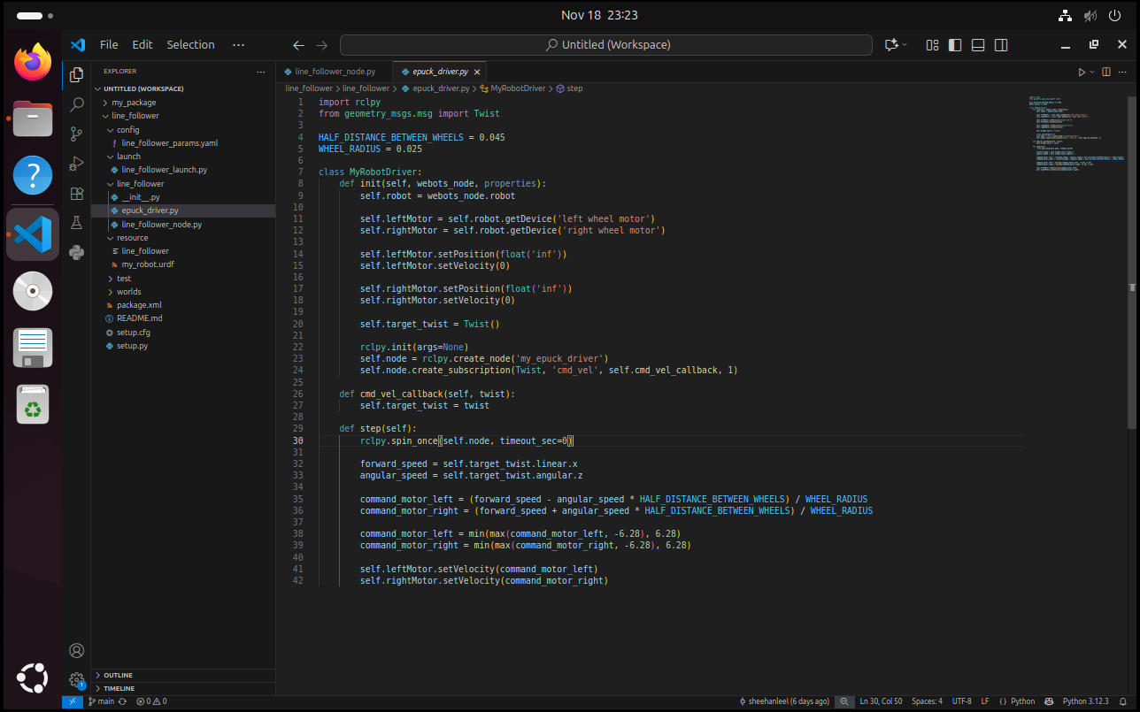
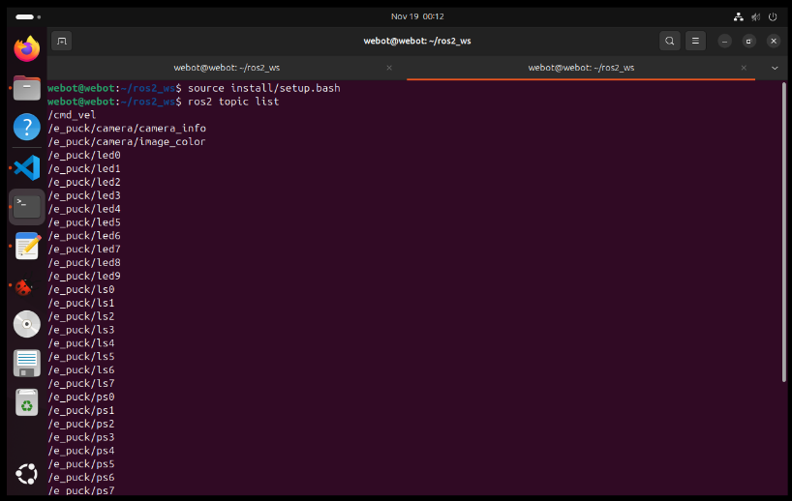
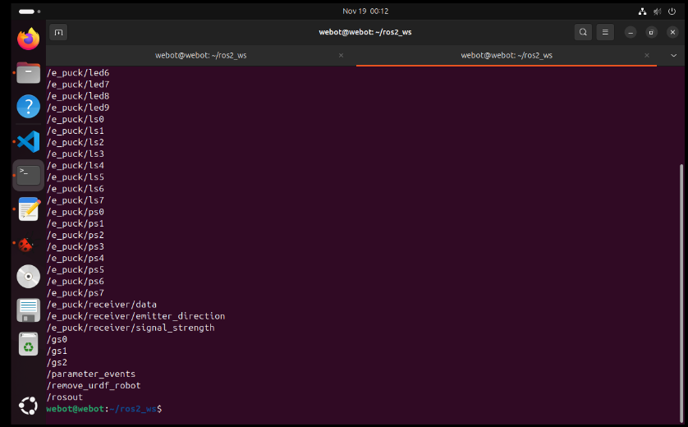
This custom plugin is ROS node equivalent to a robot controller. This allowed me to access the webots robot API and create my own node topic to control the e-puck. With access of the API I was able to connect to the e-pucks left and right wheel motors. I also created a node “cmd_vel” where I can publish and move and turn the robot. I’m using rclpy Twist to convert the published message to set the linear x and angular z of the e-puck. I also added the e-puck’s motors’ specifications to calculate or replicate the speed of an e-puck in real life or webot’s. Being able to access the api also allows you to have the e-pucks topics and nodes to be online.

urdf file:
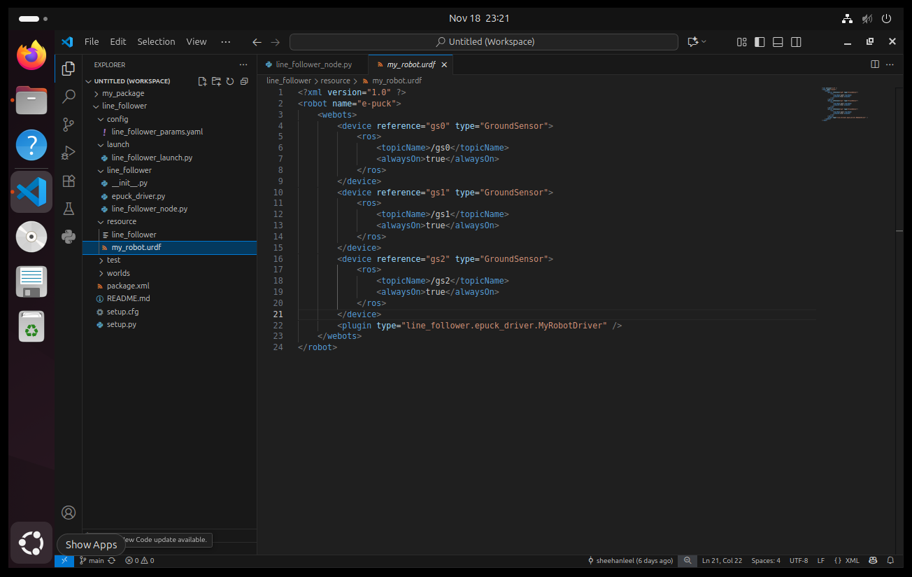
From the documentation I learned that creating an urdf file was very crucial on connecting the robot to the external ros2 controller. Firstly, I had to configure my e-puck in my webots simulation world. I had to make sure that the e-puck’s controller is set to <extern> and its name is exactly ‘e-puck’ as you can see in the URDF file. Then I declared the plugin in the urdf file, so my launch file will be able to connect it to the e-puck.

My launch file:
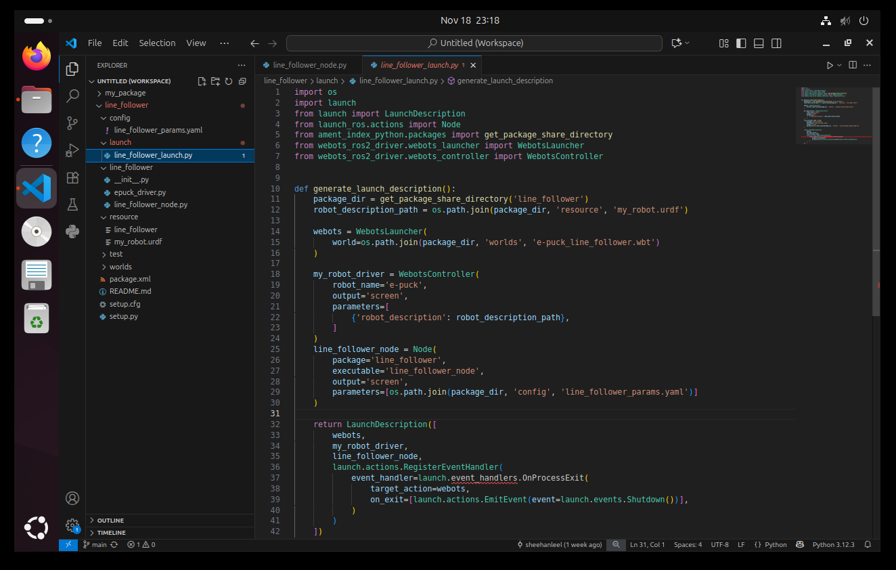
I simply just followed the documentation’s instructions were added the webot_ros2 drivers and declared where are my files are such as the package, urdf, and the wbt webots world file. “WebotsLauncher” is a imported from the webots_ros2 and it’ used to launch the webots world simulation then I used the import “WebotsController” to connect to the <extern> in webots and declared the corresponding parameters such as the robot’s name and urdf. Lastly, all I needed to do is to return and it will launch if “ros2 launch” is called in the terminal.

setup.py:
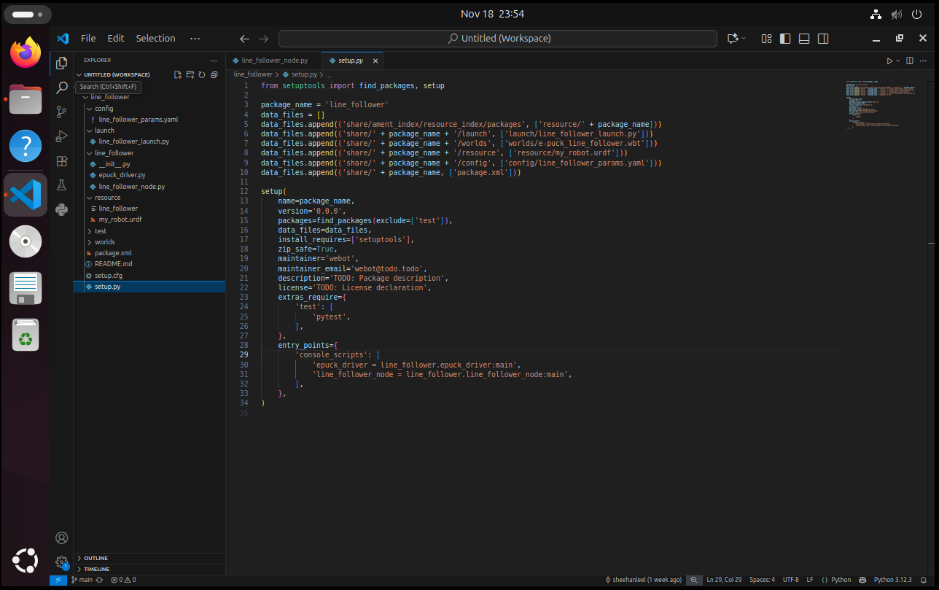
This is for the colcon build, to know where and which files are going to be built as a package. But an important point to look at is the entry point. As you can see, anything that is used as a controller that has a node or controls the robot should be declared as an entry point. With these I’m able to do accomplish my goal of controlling the e-puck to move forward.

- Built the package using colcon build
- Launch the wbt file
- Connect the plugin as a controller for the e-puck
- Created and activated cmd_vel node to publish the e-puck’s movement
- E-pucks topic and node are all activated (sensors)

Then I proceeded to my next goal to fulfill the assessment’s requirements that is to make it line following. With the help of the next documentation ‘Setting up a robot simulation (Advanced)’
Webots_ros2 drivers contain plugins to interface most of Webots devices with ROS 2 directly, these plugins can be loaded using the urdf file of the robot. The reference should match the webots’s device name parameter. In our case, we would need to load ground sensors.
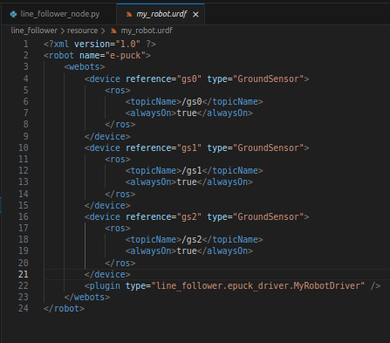
I created a node file to subscribe to the topics of the e-puck’s ground sensor.
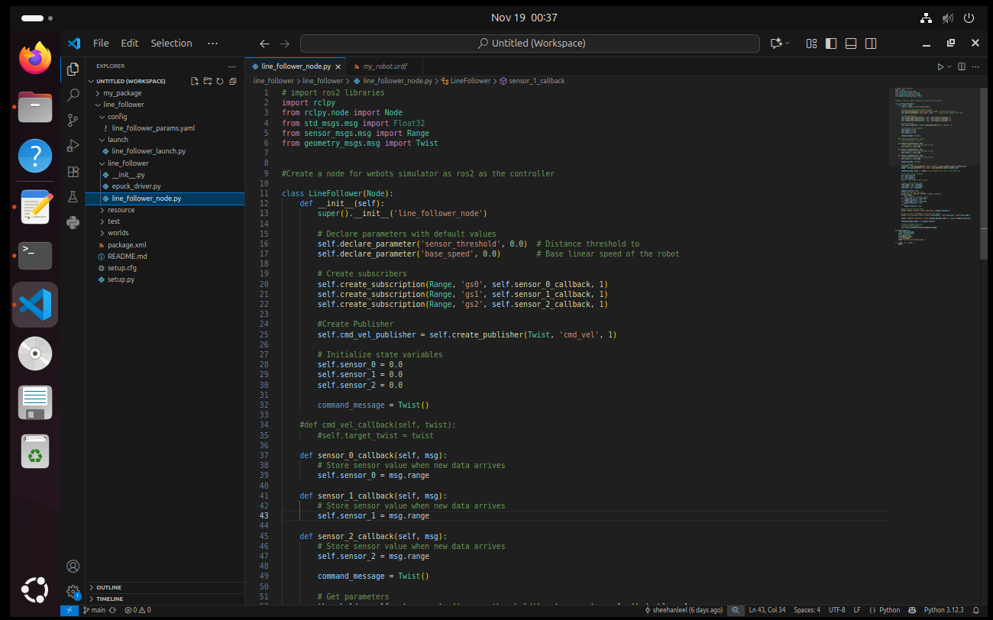
With this I’m able to fetch the ground sensor’s reading and use that for the line following behavior.
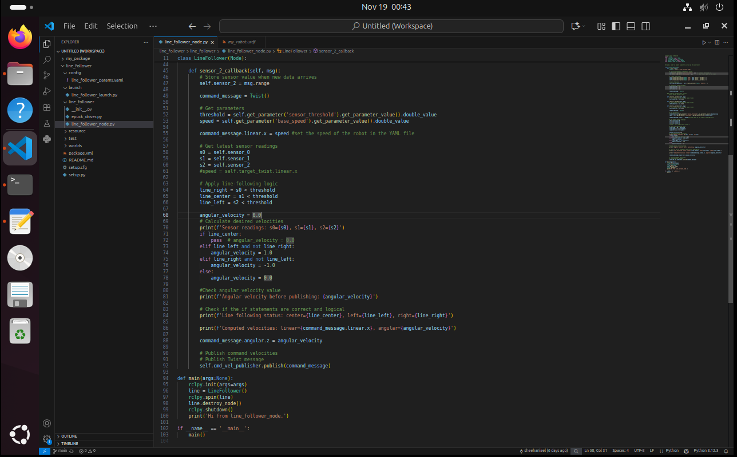
Added parameters to use for the line following behavior and e-puck base speed:
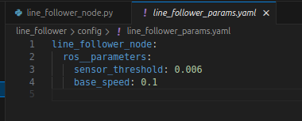
I also needed to update the setup.py, launch file
Setup.py:
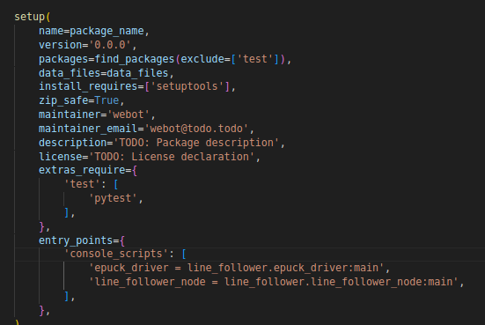
Launch file:
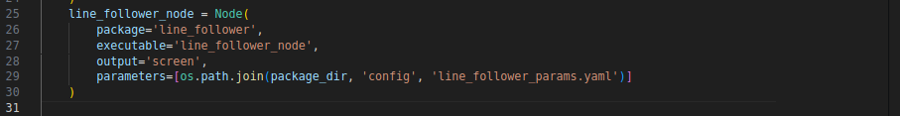
I’m using rcply spin to publish to cmd_vel 0.1(from the yaml) to move the e-puck and then with the subscribed ground sensors I was able to use the readings to my line following logic and make the robot turn to follow the line.
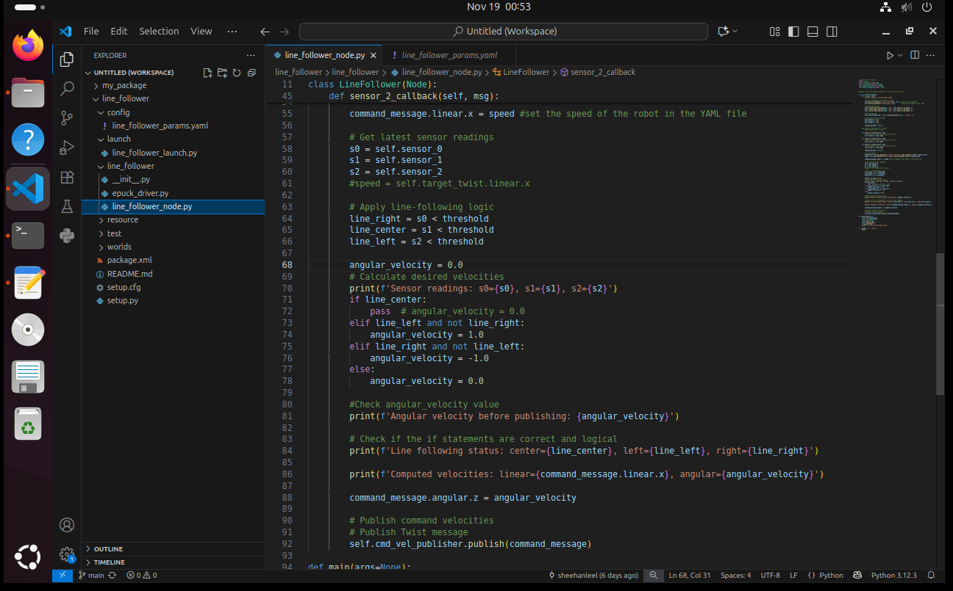
With these components, I’m able to fulfill the requirements.

TLDR: I could publish my own linear.x to cmd vel but the robots move bit by bit. Its not smooth like rcply spin.

